FLOWCHART

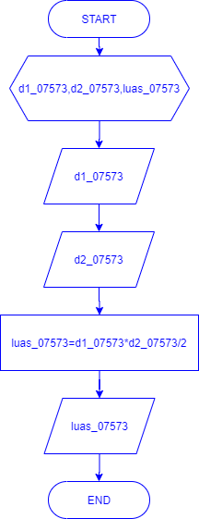

SOURCE CODE

#include <iostream>

#include <math.h>

using namespace std;

int main () {

double d1_07573,d2_07573,luas_07573;

cout <<"## Menghitung Luas Belah Ketupat ##" <<endl;

cout <<"===================================" <<endl ;

cout <<endl;

cout <<"masukan d1_07573: " ;

cin >> d1_07573;

cout <<"masukan d2_07573: " ;

cin >> d2_07573;

luas_07573=d1_07573*d2_07573/2;

cout <<"hasil luas_07573: " <<luas_07573 <<endl;

cout <<"====================================" ;

return 0;

}